PROJECT REPORT OF CO-OP Project at Industry (Module-2)
ON
The Influence of Visualization Design on Decision-Making
submitted in partial fulfilment of the requirements for the award of degree of

BACHELOR OF ENGINEERING
In
COMPUTER SCIENCE AND ENGINEERING

Submitted by: Supervised By:
Saumya Jain Dr. Shikha Tuteja
2210990805 Associate Professor
Chitkara University


DEPARTMENT OF COMPUTER SCIENCE AND ENGINEERING

CHITKARA UNIVERSITY INSTITUTE OF ENGINEERING AND TECHNOLOGY
CHITKARA UNIVERSITY, PUNJAB, INDIA

CONTENTS

S.No. | Title | Page No.
 | Acknowledgement | iv
 | List of Figures and Tables | v
 | Abstract | vi
1 | Introduction | 7
2 | Methodology | 8-9
3 | Tools and Technologies | 10-11
4 | Implementation | 12-13
5 | Major Findings/Outcomes/Output/Results | 14-15
6 | Conclusion and Future Scope | 16-17
 | References | 18-19
 | Appendices | 20-24

DECLARATION

I hereby certify that the work which is being presented in the project report entitled The Influence of Visualization Design on Decision Making in partial fulfilment of requirement for the award of the degree of Bachelor of Engineering (Computer Science and Engineering) submitted in the department of Computer Science and Engineering at Chitkara University Institute of Engineering and Technology, Chitkara University, Punjab, India, is an authentic record of my own work carried out under the supervision of Dr. Shikha Tuteja. The matter presented in this project report has not been submitted in any other university/institute for the award of any degree.

Place : Rajpura Saumya Jain
Date : 18th May 2026 (University Roll No 2210990805)

This is to certify that the above statement made by the candidate is correct to the best of my knowledge and belief.

Dr. Shikha Tuteja
Associate Professor
Department of Computer Science and Engineering
Chitkara University Institute of Engineering and Technology,
Chitkara University, Punjab, India

ACKNOWLEDGEMENT

I would like to express my sincere gratitude to all those who have supported and guided me throughout the completion of this Research titled The Influence of Visualization Design on Decision-Making.

I am highly thankful to my mentor, Dr. Shikha Tuteja, for her continuous guidance, valuable suggestions, and encouragement at every stage of this project. Her expertise and insights have been instrumental in shaping the direction and quality of this work.

I would also like to extend my appreciation to the faculty members of the Department of Computer Science and Engineering, Chitkara University, for providing the necessary academic support and resources required for the successful completion of this project.

I am grateful to my organization and team members for their support, cooperation, and for providing a practical environment to understand real-world applications of the concepts used in this project.

Lastly, I would like to thank my family and friends for their constant motivation, encouragement, and moral support, which helped me stay focused and complete this work successfully.

LIST OF FIGURES AND TABLES

List of Figures:

S. No. | Figure No. | Title | Page No.
1 | Fig. 1 | Workflow of Visualization Influence on Decision-Making | 22
2 Fig. 2 Sample Dataset 20
3 Fig. F.1 Decision Accuracy Improvement 23
4 Fig. F.2 Decision Time Reduction 23
5 Fig. F.3 User Engagement Improvement 24
6 Fig. F.4 Literature Trend Analysis 24

List of Tables:

S. No. | Table No. | Title | Page No.

1 | Table 1 | Survey Findings Summary 14

2 | Table 2 | Organization-wise Analysis 14

3 | Table 3 | Ethical Practices and Awareness Comparison 15

ABSTRACT

Data visualization plays a critical role in modern decision-making by transforming complex information into understandable visual formats such as charts, graphs, and dashboards. While visualizations are often perceived as objective representations of data, design choices can significantly influence interpretation and decision-making. Elements such as axis scaling, chart selection, colour schemes, and layout may unintentionally—or deliberately—distort information and guide viewers toward biased conclusions.
This research investigates how visualization design affects human perception, cognitive bias, and organizational decision-making. The study focuses on common visualization pitfalls, including truncated axes, misleading chart formats, decorative elements, and framing effects. It also examines how cognitive biases such as confirmation bias and framing influence the interpretation of visual information.
A survey-based research methodology was adopted, involving organizations from industries such as IT, healthcare, finance, education, and manufacturing. The findings reveal that although organizations heavily rely on visualization tools like Power BI, Tableau, and Excel, many still experience issues related to misinterpretation and lack structured ethical visualization practices.
The research highlights the importance of ethical visualization design, transparency, and data literacy in reducing misleading interpretations and improving decision quality. The study concludes that data visualization is not inherently neutral and that responsible design practices are essential to ensure fair, accurate, and reliable communication of information.

Keywords: Data Visualization, Decision-Making, Cognitive Bias, Ethical Visualization, Data Literacy, Visual Perception, Information Distortion, Transparency

- INTRODUCTION

In today’s digital era, data has become one of the most valuable assets for organizations, governments, businesses, and individuals. Every day, enormous amounts of information are generated through online platforms, business operations, healthcare systems, financial transactions, education systems, and social media. To make this complex information understandable and useful, data visualization has emerged as an essential communication tool. Visualization transforms raw numerical data into graphical formats such as charts, graphs, dashboards, and infographics, allowing users to quickly identify trends, comparisons, patterns, and insights.
Over the years, organizations have increasingly relied on visual analytics for decision-making because visual representations simplify complicated datasets and make information easier to interpret. Business managers use dashboards to monitor performance, healthcare professionals rely on visual reports to analyze patient trends, and policymakers use graphs and charts to support strategic planning. Due to their clarity and accessibility, visualizations are often trusted as objective and unbiased representations of information.
However, despite their usefulness, data visualizations are not always neutral. Every visualization involves a series of design choices, including chart type, axis scaling, colour selection, layout arrangement, and data emphasis. These design elements can significantly influence how viewers interpret the same dataset. For example, truncated axes can make small differences appear dramatic, while inappropriate chart formats may distort relationships between values.
Human perception is naturally influenced by visual cues, making individuals vulnerable to cognitive biases such as confirmation bias, framing effects, and anchoring bias. People often rely on visual impressions rather than carefully analyzing numerical values, which means that subtle design manipulations can shape opinions and decision-making without the viewer realizing it. As a result, misleading visualizations may lead to incorrect conclusions, flawed strategies, operational inefficiencies, and poor decision outcomes.
The issue becomes more critical in high-stakes sectors such as finance, healthcare, public policy, and business intelligence, where inaccurate interpretation of visual data can have serious consequences. In some cases, visualizations may even be intentionally manipulated to influence opinions, support specific agendas, or create misleading narratives. This raises important ethical concerns regarding transparency, accountability, and responsible communication of information.
- METHODOLOGY

The research adopts a descriptive and analytical methodology to examine how visualization design influences human perception, interpretation, and decision-making. The primary objective of the methodology is to understand how different visual representations of the same dataset can affect user judgment, confidence, and analytical conclusions. Since modern organizations heavily depend on dashboards, charts, and graphical reports for business intelligence and strategic planning, the study focuses on identifying whether visual design choices can unintentionally or intentionally distort information and influence decisions.
The first phase of the methodology involved defining the research objectives and identifying the major factors associated with misleading data visualization. Extensive literature review and background research were conducted using academic journals, research papers, case studies, and online publications related to cognitive bias, visual analytics, ethical visualization practices, and decision-making psychology. This helped in identifying common visualization issues such as truncated axes, misleading colour usage, improper scaling, selective data emphasis, and inappropriate chart selection. The literature review also provided insights into how cognitive biases such as framing effects, anchoring bias, and confirmation bias influence the interpretation of visual information.
After defining the research scope, the next stage involved data collection through surveys and visualization experiments. A structured questionnaire was prepared and distributed among professionals, students, and employees working in industries such as healthcare, finance, education, manufacturing, retail, and information technology. These sectors were selected because they frequently rely on data visualization tools for reporting, monitoring performance, forecasting, and strategic decision-making. The survey aimed to gather information regarding visualization usage, common interpretation challenges, ethical awareness, and confidence levels while interpreting visual data.
To analyze the effect of visualization design, multiple versions of the same datasets were created using different chart types, layouts, and visual encoding techniques. The datasets were represented using bar graphs, line charts, pie charts, dashboards, and comparison visuals. Several visualizations intentionally included misleading elements such as manipulated axis scales, disproportionate graphical representation, excessive decorative elements, and misleading colour gradients. Participants were shown these visualizations and were asked to identify patterns, compare values, predict trends, and make decisions based on the presented information. Their responses were carefully recorded to evaluate whether the design influenced their understanding and conclusions.
The methodology also included comparative analysis between correctly designed visualizations and misleading visualizations. The purpose of this comparison was to observe how even minor design modifications can alter interpretation and affect confidence levels. Participants often interpreted the same dataset differently depending on the visual structure and presentation style. This demonstrated that visualization design has a direct impact on perception and analytical reasoning, even when the underlying numerical data remains unchanged.
The collected responses and survey data were analyzed using both qualitative and quantitative approaches. Quantitative analysis was performed to calculate percentages, trends, and response distributions, while qualitative analysis focused on understanding participant opinions, reasoning patterns, and visualization preferences. Statistical interpretation methods were applied to evaluate the influence of different visual elements on decision-making behaviour. The study also examined organizational awareness regarding ethical visualization practices and whether companies provide proper data literacy or visualization training to employees.
Another important aspect of the methodology was the evaluation of cognitive biases associated with visual interpretation. The research examined how framing effects influence the way information is perceived depending on its presentation style. It also analyzed how confirmation bias causes individuals to interpret visuals in a manner that supports their existing beliefs or assumptions. By incorporating psychological and behavioural analysis, the methodology provided a deeper understanding of the relationship between human cognition and visual communication.
Finally, the research findings were interpreted to identify key challenges, ethical concerns, and opportunities for improvement in visualization design practices. The methodology successfully demonstrated that visualization design significantly affects interpretation, understanding, and decision-making processes. It also highlighted the importance of transparency, ethical standards, and data literacy in reducing the risks associated with misleading visual communication.
.
.

- TOOLS AND TECHNOLOGIES

The successful implementation of this research project required the use of various tools, technologies, and analytical platforms for data collection, visualization creation, statistical analysis, and report preparation. These tools helped in conducting visualization experiments, analyzing participant responses, and studying the influence of graphical design on human decision-making. The combination of data analysis software, visualization platforms, and survey tools enabled efficient execution of the research methodology and accurate interpretation of the findings.
The primary programming language used in this project was Python due to its simplicity, flexibility, and extensive support for data analysis and visualization libraries. Python provided an efficient environment for processing datasets, analyzing survey responses, and generating visual comparisons. Libraries such as Pandas were used for handling and organizing structured datasets. Pandas made it easier to clean, filter, manipulate, and analyze large volumes of survey and visualization-related data. The library also helped in converting raw information into meaningful analytical outputs.
For graphical representation and visualization experiments, the Matplotlib library was used extensively. Matplotlib allowed the creation of various chart types such as bar graphs, line charts, pie charts, and comparative visuals. Different visualization styles were generated using varying axis scales, colour schemes, and layouts to study how design modifications affect user interpretation. These visualizations formed the core experimental component of the research.
In addition to Python-based visualization libraries, professional business intelligence and visualization platforms such as Tableau and Microsoft Power BI were also used. Tableau provided interactive dashboard capabilities and advanced graphical customization features, enabling the creation of realistic business-oriented visual reports. Power BI was used to simulate organizational dashboards and data analytics environments commonly used in industries. These platforms helped in demonstrating how visualization design influences decision-making in practical business scenarios.
Microsoft Excel played an important role in organizing datasets, calculating statistical summaries, and creating basic analytical charts. Excel was particularly useful for preliminary data analysis, percentage calculations, and tabular representation of survey results. Statistical analysis and interpretation of participant responses were further enhanced using SPSS, which provided tools for quantitative evaluation, trend analysis, and response comparison. SPSS helped in understanding how participants interpreted different visual representations and how visualization styles influenced their decisions and confidence levels.
Google Forms was used as the primary survey collection platform for gathering participant responses. The tool enabled efficient distribution of questionnaires among respondents from multiple industries and educational backgrounds. It also simplified data collection and automatic response organization, making the analysis process faster and more manageable. The survey responses collected through Google Forms were later exported and analysed using Python and statistical software.
Canva and Microsoft PowerPoint were utilized for creating diagrams, workflow illustrations, presentation slides, and graphical summaries related to the research project. These tools helped in designing visually appealing representations of findings, methodology workflows, and comparative visualization examples. PowerPoint was also useful for preparing project presentations and demonstrating experimental results in a clear and understandable manner.
Apart from software tools, the research incorporated concepts from cognitive psychology, ethical data representation, visual analytics, and human-computer interaction. Techniques related to comparative visualization analysis, cognitive bias evaluation, and ethical assessment were applied throughout the study to analyze how visual design influences human thinking and decision-making behaviour. The integration of technical tools and analytical concepts ensured that the research was both technically strong and conceptually meaningful.
Overall, the combination of Python, visualization platforms, statistical tools, survey applications, and analytical techniques provided a comprehensive environment for conducting the research successfully. These tools not only supported accurate data analysis and visualization experimentation but also helped in understanding the broader relationship between design, perception, ethics, and decision-making in modern data-driven environments.

- IMPLEMENTATION

The implementation phase of the project focused on examining how different visualization designs influence interpretation, perception, and decision-making among users. The implementation process involved collecting datasets, creating multiple visualization formats, conducting survey-based experiments, analyzing participant responses, and evaluating the overall impact of visualization design on human judgment. The complete implementation was carried out using a combination of visualization platforms, statistical tools, and data analysis techniques to ensure accurate and meaningful results.
The first stage of implementation involved preparing and organizing the datasets used for visualization experiments. Sample datasets containing numerical and categorical information related to business performance, healthcare statistics, financial growth, sales analysis, and organizational reports were selected. These datasets were chosen because such information is commonly represented through dashboards and visual analytics tools in real-world environments. The collected data was cleaned, structured, and organized using Microsoft Excel and Python libraries such as Pandas to ensure consistency and accuracy before creating visual representations.
After preparing the datasets, multiple visualization versions of the same information were designed using different chart types and visual encoding techniques. Charts such as bar graphs, line graphs, pie charts, dashboards, comparison charts, and trend analysis visuals were created using tools including Tableau, Power BI, Matplotlib, and Microsoft Excel. Each visualization was intentionally designed with different styles, layouts, colours, and scaling methods to observe how these changes affect human interpretation. Some charts were created using proper visualization practices, while others included misleading elements such as truncated axes, exaggerated scaling, distorted proportions, misleading colour intensities, and inappropriate chart selections.
The implementation also focused on understanding the psychological impact of visual elements on viewers. Participants were shown different versions of the same dataset and were asked to interpret patterns, compare results, identify trends, and make decisions based on the presented information. For example, participants were required to determine whether a business was performing positively or negatively, whether a trend was increasing significantly, or whether a comparison indicated major differences between categories. The responses helped identify how visualization design influences analytical thinking and decision-making behaviour.
To conduct the experimental study effectively, surveys and visualization assessments were distributed using Google Forms. Participants from different educational backgrounds and industries such as healthcare, finance, education, manufacturing, and information technology participated in the study. Their interpretations, confidence levels, and observations were recorded and analyzed carefully. The responses revealed that even small modifications in visual design significantly changed the way participants understood the same dataset. In many cases, misleading visualizations resulted in exaggerated interpretations and incorrect conclusions despite the data itself remaining unchanged.
The implementation process also included comparative analysis between ethical and misleading visualizations. Properly designed charts followed principles such as accurate scaling, appropriate colour usage, balanced layout design, and clear labeling. In contrast, misleading charts intentionally violated these principles to study their effect on user perception. The comparison demonstrated that users were more likely to trust and confidently interpret visually appealing or exaggerated charts, even when those charts presented distorted information. This highlighted the importance of ethical visualization practices and transparent communication of data.
Statistical and analytical techniques were then applied to evaluate participant responses and identify patterns related to visualization influence. Python libraries, SPSS, and Microsoft Excel were used to calculate response distributions, interpretation accuracy, confidence percentages, and comparative results. Quantitative analysis helped measure the level of misinterpretation caused by misleading visualizations, while qualitative analysis provided insights into participant reasoning and perception patterns.
Another important part of the implementation involved studying cognitive biases associated with visual interpretation. The project examined how framing effects influenced decisions when the same information was presented in different visual formats. It also analyzed how confirmation bias caused individuals to interpret visualizations according to their existing assumptions or expectations. These behavioural observations strengthened the understanding of the relationship between visualization design and psychological interpretation.
.

- MAJOR FINDINGS AND RESULTS

5.1 Visualization Usage
All surveyed organizations actively use visualization tools for reporting and decision-making.
Tools | Usage
Power BI | High
Tableau | High
Excel | Moderate
Google Data Studio | Moderate

5.2 Misinterpretation Issues
Approximately 70% of organizations reported experiencing misinterpretation of visual data at least once.
Impact Levels
- High Impact - 40%
- Medium Impact - 30%
- Low Impact - 30%

5.3 Ethical Awareness
Only 40% of organizations consistently followed ethical visualization guidelines or provided employee training on data literacy.

5.4 Key Observations
- Visualization design strongly influences decision-making
- Truncated axes and misleading colours distort perception
- Cognitive biases affect interpretation accuracy
- Ethical visualization practices reduce misinterpretation risks
- Data literacy improves critical evaluation of visual information

- CONCLUSION AND FUTURE SCOPE

6.1 CONCLUSION
The rapid growth of digital technologies and data-driven systems has transformed the way organizations collect, analyze, and communicate information. In today’s modern world, data visualization has become one of the most widely used techniques for simplifying complex datasets and supporting decision-making processes. Organizations across industries such as healthcare, finance, education, manufacturing, retail, and information technology rely heavily on visual dashboards, charts, graphs, and analytical reports to monitor performance, identify trends, and make strategic decisions. Because visual representations are easier to understand than raw numerical data, they are often considered reliable and objective sources of information. However, this research demonstrates that data visualization is not always neutral and that design choices can significantly influence interpretation, perception, and decision-making.
The primary objective of this research was to study how visualization design affects human judgment and to examine the role of cognitive bias and ethical considerations in visual communication. Through survey-based analysis, comparative visualization experiments, and participant interpretation studies, the research successfully identified that even when the underlying data remains accurate, the method of presentation can alter how people understand and respond to information. Design elements such as chart type, colour selection, axis scaling, data emphasis, layout structure, and graphical proportions were found to have a major impact on user interpretation and confidence levels.
One of the most important findings of the study is that misleading visualizations can influence decision-making without users being fully aware of the manipulation. Participants often interpreted the same dataset differently depending on the visual representation used. Visualizations containing truncated axes, exaggerated colour schemes, distorted scaling, or inappropriate chart types frequently created stronger emotional reactions and more dramatic interpretations compared to properly designed visuals. This demonstrates that visualization design has the power to shape perception and influence analytical reasoning even when the data itself has not changed.
6.2 FUTURE SCOPE
Although the research successfully demonstrates the influence of visualization design on perception and decision-making, there are several opportunities for future improvement and expansion. One important direction for future work is expanding the research across a larger and more diverse population. Conducting studies involving participants from different countries, cultures, educational backgrounds, and professional industries can provide deeper insights into how visualization interpretation varies across different groups and environments.
Future research can also focus on advanced and interactive visualization systems. With the rapid advancement of Artificial Intelligence, Machine Learning, and Business Intelligence technologies, modern dashboards are becoming more automated and interactive. AI-generated visualizations and recommendation systems may introduce new forms of bias or manipulation that require detailed investigation. Studying how automated visualization tools influence perception and trust will become increasingly important in the future.
Another potential improvement is the development of standardized ethical visualization frameworks and guidelines that organizations can adopt while designing reports, dashboards, and analytical systems. Such frameworks can help reduce misleading practices and promote transparency in visual communication. Organizations may also integrate ethical review processes for visual analytics similar to quality assurance practices used in software development and reporting systems.
Future studies can further explore the relationship between cognitive psychology and visual interpretation. Research involving eye-tracking systems, behavioural analytics, and neuroscience-based approaches can help understand how users visually process information and how attention patterns influence decision-making. This can provide more scientific insights into human interaction with visual data and improve the design of user-centred visualization systems.
The integration of visualization literacy training programs within organizations and educational institutions is another important future direction. Many individuals rely heavily on dashboards and visual reports without understanding how design choices can affect interpretation. Developing educational programs that teach people how to critically evaluate charts, graphs, and visual analytics can significantly reduce the risk of misinterpretation and manipulation.
- REFERENCES

- Park, S., Bekemeier, B., Flaxman, A. D., & Schultz, M. (2022). Impact of data visualization on decision-making and its implications for public health practice.
- Eberhard, K. (2023). The effects of visualization on judgment and decision-making.
- Wall, E., et al. (2021). Exploring interaction traces to mitigate human biases.
- Sinha, A. (2024). Data visualization pitfalls: A systematic review.
- Zhang, Q. (2024). The impact of interactive data visualization on decision-making in business intelligence.
- Budhwani, M. (2025). The role of data visualization in communication design.
- OpenStax. (2023). Ethics in visualization and reporting.
- Wesslen, R., et al. (2020). Cognitive biases in interactive data visualizations. [14] A. R. Hevner, S. T. March, J. Park, and S. Ram, “Design Science in Information Systems Research,” MIS Quarterly, vol. 28, no. 1, pp. 75–105, 2004.

- APPENDICES

8.1 Appendix A: Survey Dataset
The dataset includes responses collected from organizations across multiple industries regarding visualization usage, awareness, ethical practices, and decision impact.

8.2 Appendix B: Visualization Experiment Samples
Different chart designs were created using:
- Bar charts
- Line graphs
- Pie charts
- Different axis scales
- Colour variations

8.3 Appendix C: Key Findings Summary
Observation | Result
Organizations using visualization tools | 100%
Misinterpretation incidents | 70%
High awareness organizations | 50%
Ethical guideline adoption | 40%

8.4 Appendix D: Ethical Visualization Recommendations
- Use accurate axis scaling
- Avoid misleading colour intensity
- Maintain transparency in presentation
- Include proper labels and context
- Promote employee data literacy training

8.5 Appendix E: Workflow Diagram
The workflow of the proposed system includes:

  - Problem Identification
  - Literature Review
  - Research Gap Identification
  - Dataset Preparation
  - Data Preprocessing
  - Statistical Analysis
  - Visualization Generation
  - Hypothesis Testing
  - Result Interpretation
  - Conclusion

Figure F.1: Workflow of Visualization Influence on Decision-Making

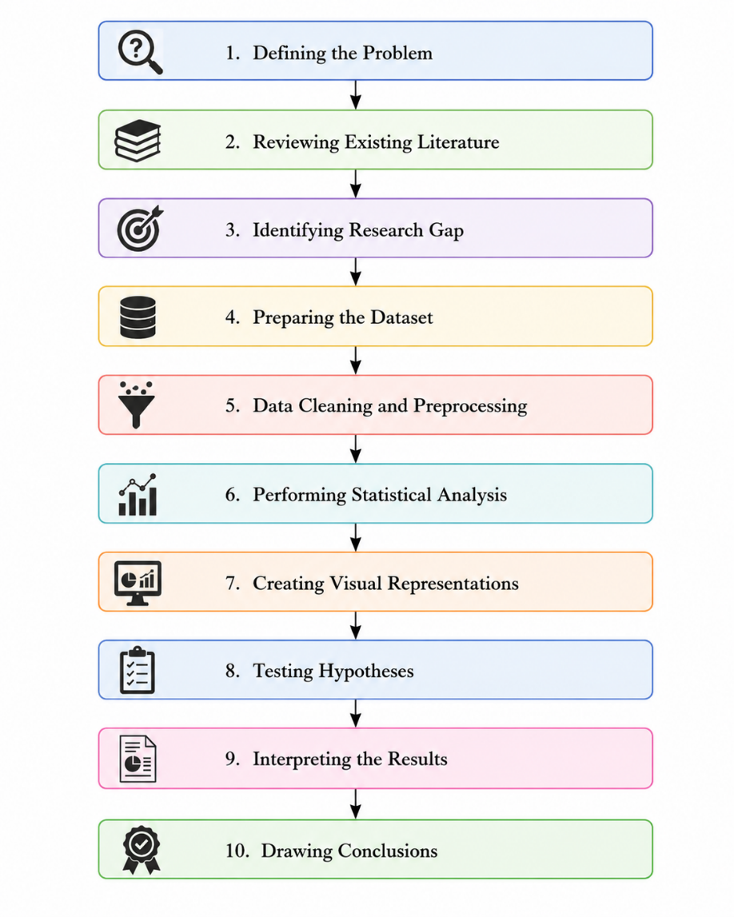

8.6 Appendix F: Output Screenshots

Figure F.2: Sample Dataset
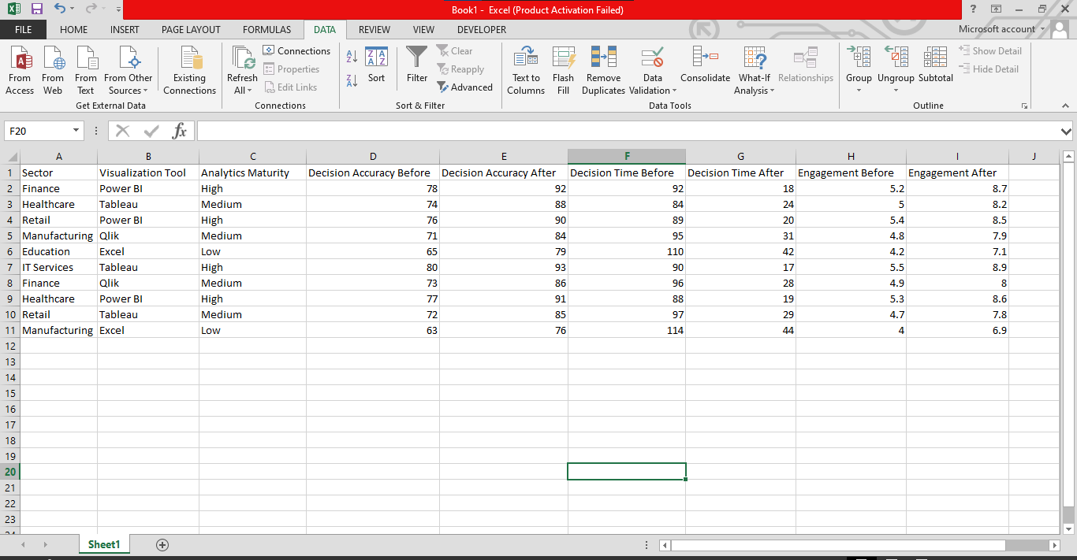

Figure F.2: Decision Accuracy Improvement
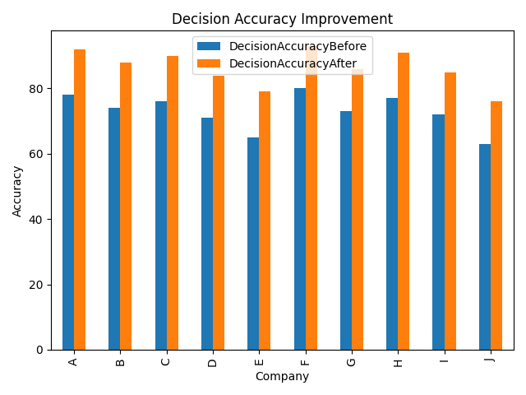

Figure F.3: Decision Time Reduction
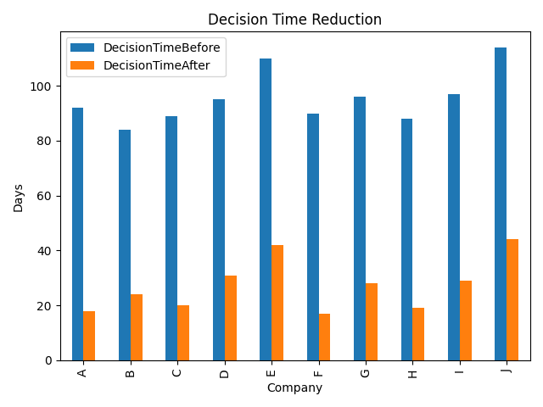
Figure F.4: User Engagement Improvement
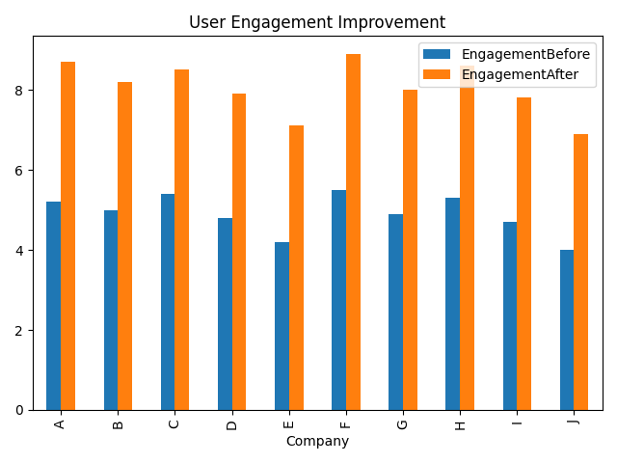

Figure F.4: Literature Trend Analysis
